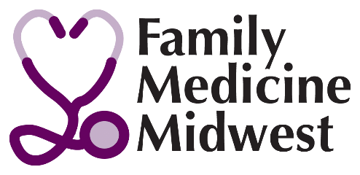

Residency Fair Exhibit Booth Form

November 10, 2018

- Yes, our Residency Program WILL PARTICIPATE in the 2018 Family Medicine Midwest Residency Fair.
Residency Exhibit Booth registration includes display booth and 1 full conference registration. Others may staff the booth during the fair hours, if not registered for the full conference.
*Two programs can share one booth space and each may have one paid registration.
- We cannot exhibit, but would like our brochure/information distributed to attendees ($200)
Please mail 250 copies of materials for delivery by October 30, 2018 (address will be provided to you)
□ Our program is interested in learning more about the Family Medicine Midwest Foundation

Residency Fair Exhibit Payment
$________ $600.00 (space with one 8’ table and one registration)

$_________ $800 for a double booth – Our demonstration will be _______________________________________

$ _________$200 to insert your program information

$ ________ $50.00 Electrical access fee

$ ________ Additional full conference registrations at $350 for physicians or $250 for residents each or Saturday only registration for $175 (you can send their names at a later date)

$_________ TOTAL AMOUNT ENCLOSED

Names of representative for your booth (if available) __________________________________
Program’s ACGME Number ____________________________________________________
Contact Person for the booth
Telephone ____________________ Email
Institution Name: ______________________________________________________________________
Mailing Address: _______________________________________________________________________
*Name of program sharing the space (if applicable) _____________________________________________________________________

P A Y M E N T
□ Check enclosed payable to Family Medicine Midwest □ Check will be mailed

Credit Card □ Discover □ Visa □ MasterCard □ American Express

Card # Signature ______________________________________

Expiration Date Sec. Code#__________ Total: $___________ Billing zip code ____________

REFUND POLICY: Written notification of cancellation must be received by October 10, 2018 to obtain a partial refund. ($50.00 administrative fee is retained). NO refunds made after Oct. 10, 2018. Mail payment to: Family Medicine Midwest c/o IAFP, 747 E. Boughton Road, Suite 253 Bolingbrook, IL 60440. Fax 630-559-0739 or email gflynn@iafp.com.
Residency Fair registrations will be accepted until September 30, 2018. Contact Ginnie Flynn with questions at 630-427-8004.

